**EXP 5** 210701227

**Create tables in Hive and write queries to access the data in the table**

**Aim:**

To create tables in Hive and write queries to access the data in the table.

**Procedure:**

**Step 1:**Download the Hive from it’s official website. Once the file get downloaded in your */downloads* folder extract this file with below command

tar -xvf apache-hive-2.1.1-bin.tar.gz

**Step 2:** Once you have downloaded the Hive now Install the latest version of MySQL java connector.

Then create a link between jar file and hive lib folder and copy jar to the lib folder.

sudo ln -s /usr/share/java/mysql-connector-java.jar $HIVE_HOME/lib/mysql-connector-java.jar

**Step 3:** Now start the Hadoop with the below command:

start-dfs.sh

start-yarn.sh

**Step 4:** Once your Hadoop gets started we will create Directories for the hive. Implement below commands in your terminal to make directories.

hdfs dfs -mkdir -p /user/hive/warehouse

hdfs dfs -mkdir -p /tmp/hive

**Step 5:** Now we will change permission for all this directory with below command.

hdfs dfs -chmod 777 /tmp/

hdfs dfs -chmod 777 /user/hive/warehouse

hdfs dfs -chmod 777 /tmp/hive

**Step 6:** Now we will install MySQL with below command.

sudo apt-get install mysql-server

**Step 7:** Create the Metastore Database after entering your MySQL terminal, implement all the below commands to do so (use **root** as password for SQL).

mysql> sudo mysql -u root -p

mysql> CREATE DATABASE metastore_db;

mysql> USE metastore_db;

Change the username according to you and path also if it is different.

mysql> SOURCE /home/{user-name}/Documents/apache-hive-2.1.1-bin/scripts/metastore/upgrade/mysql/hive-schema-0.14.0.mysql.sql;

**Step 8:** Now make hive user and hive password with below command on *mysql* terminal.

mysql> CREATE USER 'hiveusr'@'%' IDENTIFIED BY 'hivepassword';

mysql> GRANT all on *.* to 'hiveusr'@localhost identified by 'hivepassword';

mysql> flush privileges;

Then type exit to quit the MySQL terminal.

mysql> exit

**Step 9:** Now go to *apache-hive-2.1.1-bin* then go to *conf* folder and rename hive-default.xml.template to *hive-site.xml* and hive-env.sh.template to *hive-env.sh*

**Step 10:** Now we start configuration for hive so go to *hive-site.xml* and change the following property.(use clrl+f to search property in a file)

*A:* ConnectionURL

|  |
| --- |
| <name>javax.jdo.option.ConnectionURL</name>  <value>jdbc:<mysql://localhost/metastore_db?createDatabaseIfNotExist=true></value> |

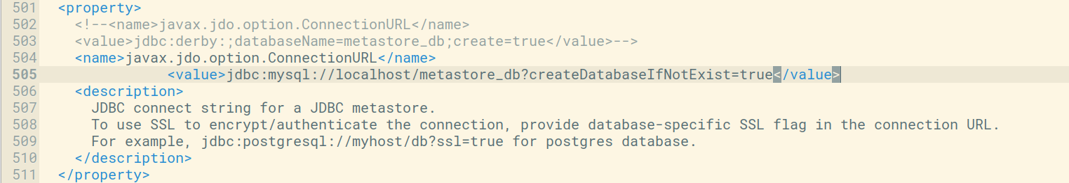

*B:* ConnectionUserName

|  |
| --- |
| <name>javax.jdo.option.ConnectionUserName</name>  <value>hiveusr</value> |

// Change username in value if you change it above.

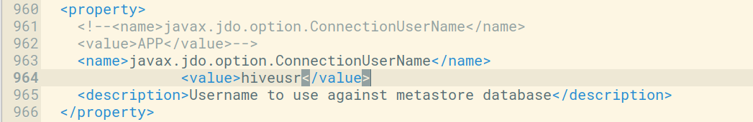

*C:* ConnectionPassword

|  |
| --- |
| <name>javax.jdo.option.ConnectionPassword</name>  <value>hivepassword</value> |

// change password in value if you change it above.

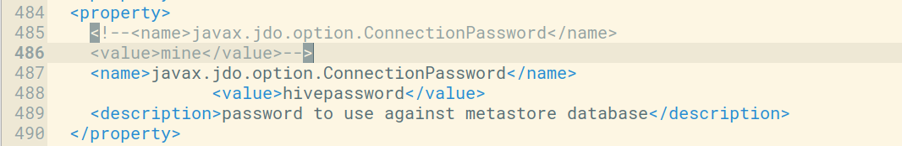

*D:* ConnectionDriverName

|  |
| --- |
| <name>javax.jdo.option.ConnectionDriverName</name>  <value>com.mysql.jdbc.Driver</value>  <description>MySQL JDBC driver class</description> |

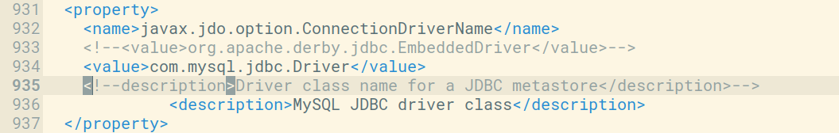

**Step 11:** Now open *hive-env.sh* and append your hadoop path inside it.

export HADOOP_HOME=/home/dikshant/Documents/hadoop

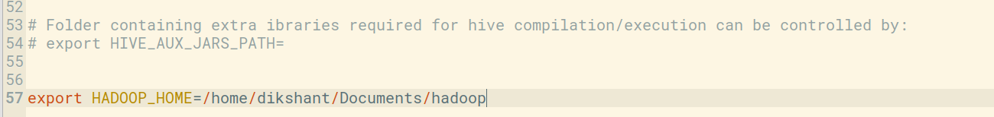

**Step 12:** Also replace the below values in hive-site.xml (search property with ctrl+f and enter the name inside search box)

*A:* Replace this properties

|  |
| --- |
| <property>      <name>hive.exec.local.scratchdir</name>      <value>${system:java.io.tmpdir}/${system:user.name}</value>      <description>Local scratch space for Hive jobs</description>    </property> |

With this property

|  |
| --- |
| <property>      <name>hive.exec.local.scratchdir</name>      <value>/tmp/${user.name}</value>      <description>Local scratch space for Hive jobs</description>    </property> |

*B:* Replace this property

|  |
| --- |
| <property>      <name>hive.downloaded.resources.dir</name>      <value>${system:java.io.tmpdir}/${hive.session.id}_resources</value>      <description>Temporary local directory for added resources in the remote file system.</description>    </property> |

With these properties

|  |
| --- |
| <property>    <name>hive.downloaded.resources.dir</name>    <value>/tmp/${user.name}_resources</value>    <description>Temporary local directory for added resources in the remote file system.</description>  </property> |

**Step 13:** Now the most important part is to set path for Hive in our *.bashrc* file, so open *.bashrc* with below command.

sudo gedit ~/.bashrc

Copy the Hive path shown in the below image and update it according to your hive path (if different).

|  |
| --- |
| #Hive Path  export HIVE_HOME=/home/dikshant/Documents/apache-hive-2.1.1-bin  export PATH=$PATH:$HIVE_HOME/bin |

source ~/.bashrc

**Step 14:** Now run this below command to initialize schema for MySQL database.

schematool -initSchema -dbType mysql

**Step 15:** that’s it now run hive shell by typing hive in terminal.

hive

**Step 16:**

# Create a Database

Create a new database in Hive:

hive>CREATE DATABASE financials;

**Step 17:**

Switch to the newly created database:

hive>use financials;

**Step 18:**

Create a simple table in your database:

hive>CREATE TABLE finance_table( id INT, name STRING );

**Step 19:**

You can insert sample data into the table:

hive>INSERT INTO finance_tableVALUES (1, 'Alice'), (2, 'Bob'), (3, 'Charlie');

**Step 20:**

Use SQL-like queries to retrieve data from your table:

hive>CREATE VIEW myview AS SELECT name, id FROM finance_table;

**Step 21:**

To see the data in the view, you would need to query the view hive>SELECT*FROM myview;

**Step 22:**

To exit the Hive CLI, simply type: hive>quit;

**OUTPUT:**

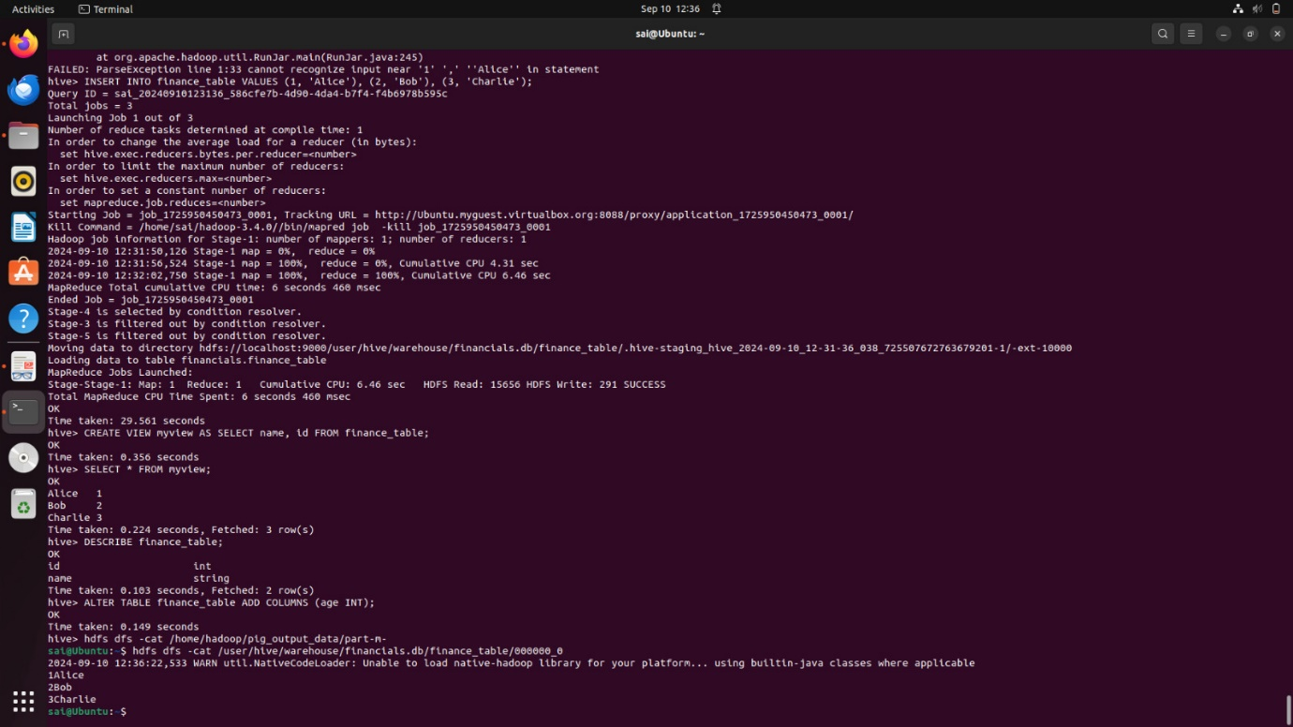

**Result:**

Thusto create tables in Hive and write queries to access the data in the table is executed successfully.